**ONI**

* The microscope and software are both controlled by the main computer (on the floor). The lasers are in the black box on the table, connected through optic fibers to the stage.
* The password to the Windows interface is ONI (with capital letters)

1. The software's name is ONI- open it through the start menu on the icon (the microscope is on as soon as the program turns on).
2. Once in the software, move from "analyze" to "acquire" tab.
3. Make sure there is nothing on the stage, then click on "connect to microscope".
4. Confirm the pop-up message and choose the default configuration option (without 0%).
5. The right side of the screen is the "view" panel (not for imaging, just for viewing) – see next page for details.
6. In order to start the camera to look at the sample, set the exposure time to 50ms and press view at the bottom left of the “view” panel.
7. When turning off the microscope, first click on "disconnect from microscope", then close the software.

**Starting to image:**

1. The objective is 100X (it is not changeable at the moment).
2. Before placing your slide, set the Z axis to 1000 (focus is usually around ~200 um).
3. Open the stage (by lifting the lid up), place your sample (inverted) and the two magnets in the sides.
4. Enable the lasers from the "view" screen.
5. Turn on the focus laser from the "view" screen.
6. Start going down in the Z axis: You can use the XBOX controller or you can use the mouse roller when it is set over the Z "target position ("view" screen), or use "Page Down" (for 1 um per click) or the error keys (for 0.1um). You should look for "half a moon" in the sub-screen (it is an interference pattern which helps asses when you are in focus).
7. Now turn on the blue laser (0.1%).
8. The screen is composed of two sub-screens: the left is the blue-green channels, the right is the red channel. You can combine the two colors for an overlay image on the left side of the acquire menu under “Image Display Options->Color Overlay”
9. In order to move inside the FOV, click on it and move with the errors (there is also a play-station joystick).

**Auto-Focus Setup:**

1. Set the focal plane to the desired focus (first by the interference image on the focus camera and then by the actual image on the view window).
2. Press Set Focus on the “view” panel on the right side (underneath the lasers bar).
3. Wait for the focus calibration to end and for a pop-up window with graphs to appear. A message will appear, then a sub-screen with graphs will appear- the upper-right graph is the important one –the straighter and longer the green line is, the better the focus is. You can confirm the message and close the graphs window.
4. Press Z lock button to activate autofocus after the calibration.
5. Remember, before removing samples you need to deactivate the autofocus by pressing the Z lock button again.

**Protocols:**

1. On the upper panel, click on Advanced 🡪 Python Console.
2. To edit a protocol, right click "edit" on the desired protocol’s name.
3. Either choose 5 frames per laser or enlarge the exposure time to 100ms (it takes the laser time to warmup).
4. n_y and n_x, the amount of FOVs which will be captured (snake shape).
5. The exposure can be controlled from the protocol or through the view panel and is identical for all laser channels.
6. The config=np.array(1,2,3,4) controls the intensity of the lasers. The order is the order of the lasers in the "view" panel.

**Set an offset from the locked focus level**

**Set the focus (according to the protocol) once**

**Lock the Z axis regardless of the focus**

**Click on "Set Focus" once arriving to the desired focus (auto)**

**Saves the chosen amount of frames in the current position**

**Opens the camera**

**Once you click on it, the view window with two frames will open**

**Camera**

**Number of frames taken in**

**the same position.**

**Move between "illumination angle","TIRF" and "HiLo".**

* **Illumination angle- regular straight light.**
* **TIRF- light in an angle (51.5º-53º). This will cause only the surface (closet to the cover slip ~100nm) to illuminate, and will therefore eliminate a lot of the noise.**
* **HiLo- light in a slightly lower angle - ~40.**

**Currently not working**

**The frequency updates according to the exposure time**

**Save stage position and go back to it by using "Restore"**

**Use 10ms or more**

**Control temperature (from 20 or higher, can't cool)**

**Channels**

**Stage axes**

**Range: -9 – 9**

**Range: -9 – 9**

**Range: -2,500 – 2,500**

**For protocols (currently not working)**

**LED lights for bright field (currently not working)**

**IR laser which is turned on all the time for auto-focus.**

**4 lasers: in order to turn on click on the laser, and set the intensity using the bars**

**Necessary intensity- about 0.1% for the blue, ~10-12% for the red**

**In order to use the lasers first click on 'Enable lasers'**

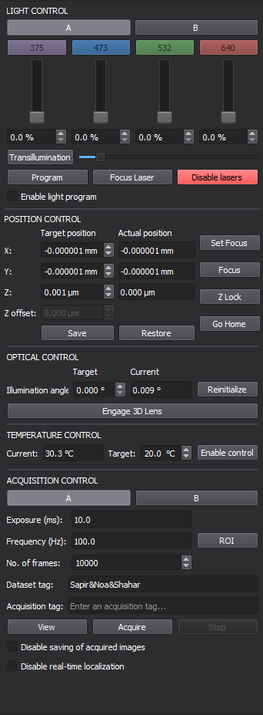

**Using the percentiles, the brightness is determined for each image by the histogram (auto)**

**Using the photons, the brightness is not determined for each image by the histogram (preset)**

**Histogram of the intensity in the viewed image**

**Controls the green-blue channel**

**Controls the red channel**

**Contrast/brightness properties of the image**

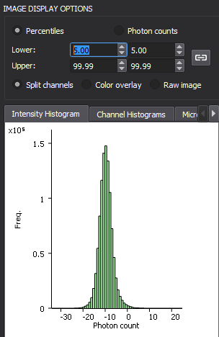

**Run**

**Main console**

